**Online Bakery Shop**

**Project Abstract**

**Version 1.0**

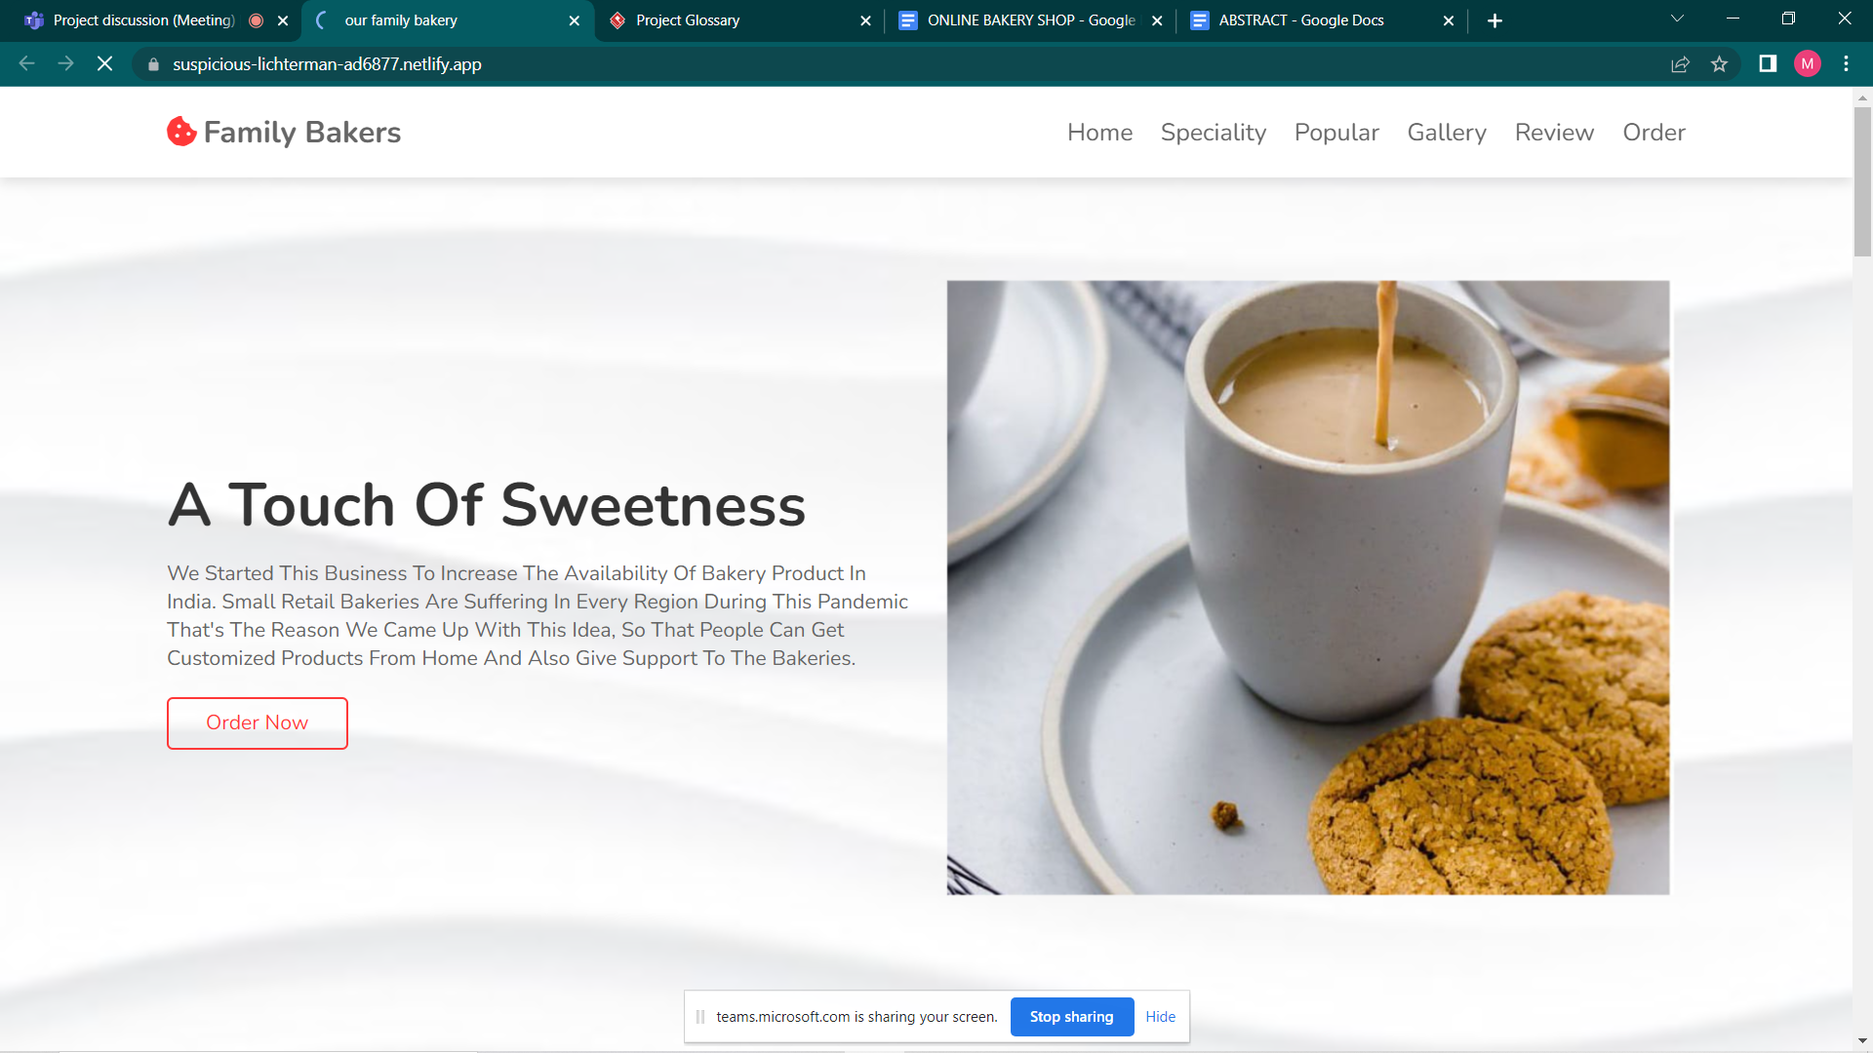

|  | Prepared By / Last Updated By | Reviewed by | Approved By |
| --- | --- | --- | --- |
| Name | 1. Md.Mehmood Alam 2. Debanjan Dhar 3. Priyanjali Das 4. Shafaque Bushra 5. Abhinaw Kumar 6. Srinjoy Gupta | <Trainer/Project Governance Representative/Cohort Mentor to fill> | <Trainer/Project Governance Representative/Cohort Mentor to fill> |
| Role | 1. POD Leader 2. POD Member 3. POD Member 4. POD Member 5. POD Member 6. POD Member |  |  |
| Signature | 1. MMA 2. DD 3. PD 4. SB 5. AK 6. SG |  |  |
| Date |  |  |  |

**Table of Contents**

1.0 Purpose of this document 4

2.0 Business Case 4

3.0 Appendices 4

3.1 Glossary 4

3.2 Other 4

4.0 Terms & Conditions 5

5.0 Change Log 5

# **1.0** **Purpose of this document**

# **An online Bakery shop that allows users to check for various bakery products available at the online store and purchase online. The project consists of list of bakery products displayed in various categories. The user may browse through these items as per categories. The goal of this project is to create a dedicated and reliable platform for foodie.**

# **2.0** **Business Case**

If the user likes a product he may add it to his shopping cart. Once user wishes to checkout he must register on the site first. He can then login using same id password next time. Now he may pay through a credit card or cash on delivery. Once the user makes a successful transaction he gets a copy of the shopping receipt on his email id. Here we use user friendly interface to make the entire frontend. The middle tier or code behind model is designed for fast processing. And SQL serves as a backend to store bakery products lists data. Thus, the online Bakery shopping project brings an entire bakery shop online and makes it easy for both buyer and seller.

**Modules:-**

· **Admin Login:** To add and remove the products

· **User Registration:** User can register on the system and get his online account on site.

· **User Login:** User can login to system and check various bakery items.

· **Product Categories:** The bakery products are arranged and can be viewed in categories.

·  **Product search :** The customer can search for specific products.

· **Add to cart:** Users can add new items to cart.

· **Dummy Credit Card Payment:** After total bill is calculated user can pay via credit card online.

# **3.0** **Appendices**

## **3.1** **Glossary**

| **Acronyms** | **Definitions** |
| --- | --- |
| 1.Admin | A person who owns the right to manage the upload and removal of products and is able to check users profile and their recent transactions. |
| 2.User | A person who can purchase products from the website and can give feedback about the product. |
| 3.Database | Necessary back-end . |
| 4.Add to cart | Selected products. |
| 5.Product search | The user can search for the specific products. |

## **3.2** **Other**

**Technology to be used:**

* Front End: HTML (HyperText Markup Language), CSS, JavaScript
* Database: MySQL
* Programming Language: Java
* Back End: MySQL, Java
* IDE (Development Tool): Eclipse
* Server used: Tomcat

# **4.0** **Terms & Conditions**

***Disclaimer: Please do not circulate or distribute this document outside of Cognizant Network, We have a Zero Tolerance Policy. Kindly adhere to 100% Compliance at all times.***

# **5.0** **Change Log**